**5*10/100/1000Base-T Industrial Ethernet Switch**

**LT-IS3005G-5GT**

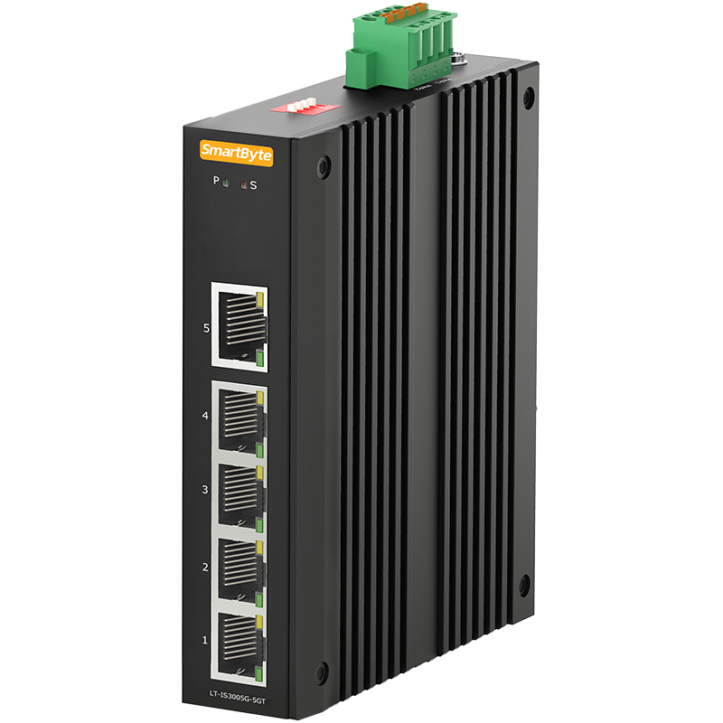

**Features:**

**➢** 4*10/100/1000Base-T RJ45 ports downlink, 1*10/100/1000Base-T RJ45 port uplink

**➢** DC 12~58V input, redundant power supply with polarity reverse/over-voltage protection

**➢** Dip switch function: 1.Port isolation; 2. Flow control; 3. QoS; 4. Broadcast storm restrain

**➢** Support 10K Bytes Jumbo frame

**➢** Support 4KV surge protection and ESD: Air-15kV, Contact-8kV Protection

**➢** IP40 fan-less and Din-rail hardware design

**➢** Operation temperature: -40 ℃ ~+75℃

**Overview**

The SmartByte LT-IS3005G-5GT is the unmanaged industrial grade Ethernet switch with 5-port 10/100/1000-T RJ45 ports. It is featuring with port isolation, flow control, QoS(1-2 ports) and broadcast storm restrain function, which all can be configured by the Dip switch on the top panel.

LT-IS3005G-5GT is also a high cost-effective easy-to-use device, which provide essential industrial Ethernet networking function, such as wide range power input 12-58VDC, redundant power design with polarity reverse/over-voltage protection, robust IP40 fan-less housing with Din-rail installation, wide operation temperature from -40°C to 75°C as well as high-level EMI/EMC capability and so on. It is the best choice for heavy industrial factory, transportation, oil & gas, chemical, IP Surveillance and processing automation area where environmental conditions exceed commercial product specifications

**Technical specification**

|  |  |  |  |  |
| --- | --- | --- | --- | --- |
| **Model No.** | LT-IS3005G-5GT | | | |
| **Interface** | Fiber port | | Copper RJ45 ports | |
| 0 | | 5 | |
| **Ethernet** | 5*10/100/1000Base-T RJ45 ports | | | |
| **Standard** | IEEE 802.3 10Base-T Ethernet  IEEE 802.3u Fast Ethernet  IEEE 802.3ab Gigabit Ethernet  IEEE 802.3x Full-Duplex Flow Control  IEEE 802.3az Energy Efficient Ethernet | | | |
| **Dip Switch** | 1. Port Isolation 2. Flow control 3. QoS(1-2 ports） 4. Broadcast storm restrain | | | |
| **LED Indicators** | P(Power indicator) Green | Off: the device is power off or failed | | |
| On: the device power on is normal | | |
| S(System indicator) Red | Off: the chip is normal | | |
| On: the chip read/write is unnormal | | |
| 1-5(Copper ports) | Green indicators | | Yellow indicators |
| Off: ports link down | | Off: port speed is 10/100M |
| On: ports link up | | On: port speed is 1000M |
| Blinking: data on TX/RX | |
| **Power parameters** | | | | |
| Input voltage | 12-58VDC, redundant power input | | | |
| Input current | 0.5A Max | | | |
| Total power consumption | Full loading ≤5W | | | |
| Connector | Removable 4-pin terminal block | | | |
| Reverse polarity protection | Support | | | |
| Over-voltage protection | Support | | | |
| **Switching features** | | | | |
| Switching capacity | 10G | | | |
| Packet forwarding rate | 14.8 Mpps | | | |
| MAC address table | 2K | | | |
| VLAN | 4K | | | |
| Buffer | 3M | | | |
| Forwarding delay | <5us | | | |
| Jumbo Frame | Support 10Kbytes | | | |
| MDX/MIDX | Support | | | |
| Watchdog | Support | | | |
| **Network Topology** | | | | |
| Star topology | Support | | | |
| Bus topology | Support | | | |
| Tree Topology | Support | | | |
| **Mechanical structure** | | | | |
| Case protection | IP40 | | | |
| Installation method | Din-rail | | | |
| Dimension(W*D*H)mm | 30*98*130mm | | | |
| Weight | 0.5 kg | | | |
| **Operating environment** | | | | |
| Operating temperature | -40℃~+75℃ | | | |
| Storage/transportation temperature | -40℃~+85℃ | | | |
| Relative humidity | 5%~95%（non-condensing） | | | |
| **Industrial Standard** | Surge protection of power: IEC 61000-4-5 Level 3 (4KV/2KV）（8/20us) | | | |
| Surge protection of Ethernet ports: IEC 61000-4-5 Level 3 (4KV/2KV）（10/700us) | | | |
| DIP: IEC 61000-4-11 Level 3（10V） | | | |
| ESD: IEC 61000-4-2 Level 4（8K/15K） | | | |
| Shock：IEC 60068-2-27 | | | |
| Free fall：IEC 60068-2-32 | | | |
| Vibration：IEC 60068-2-6 | | | |
| **Certification** | CCC/CE/FCC/RoHS | | | |
| **Warranty** | 5 years | | | |

**Structure diagram**

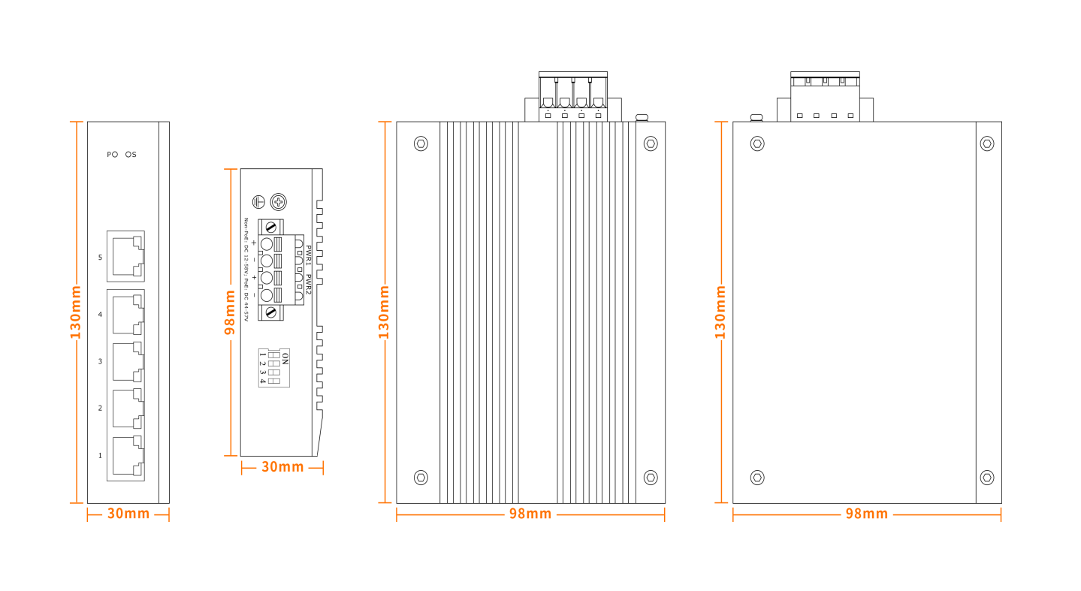

**Order information**

|  |  |
| --- | --- |
| Model | Description |
| LT-IS3005G-5GT | 5-port 10/100/1000Base-T industrial Ethernet switch, DC12-58V input, redundant dual power supply, Din-rail installation. Operation temperature: -40℃～+75℃ |